**Matter:** Workshop 2 Technical Report

Carlos Andres Sierra-Docente

Universidad Distrital- School of Engineering

software-modeling

**Introduction:**

We have tried to improve the first delivery of the task, in which we wanted to implement: more attributes for the class car and yacht, a different method to calculate the consumption of tractors, that the engines would be created separately and not duplicate objects when creating vehicles.

**Statement of facts:**

For the creation of the motors, a design pattern was proposed For the creation of the motors, a design pattern was proposed “Abstract Factory”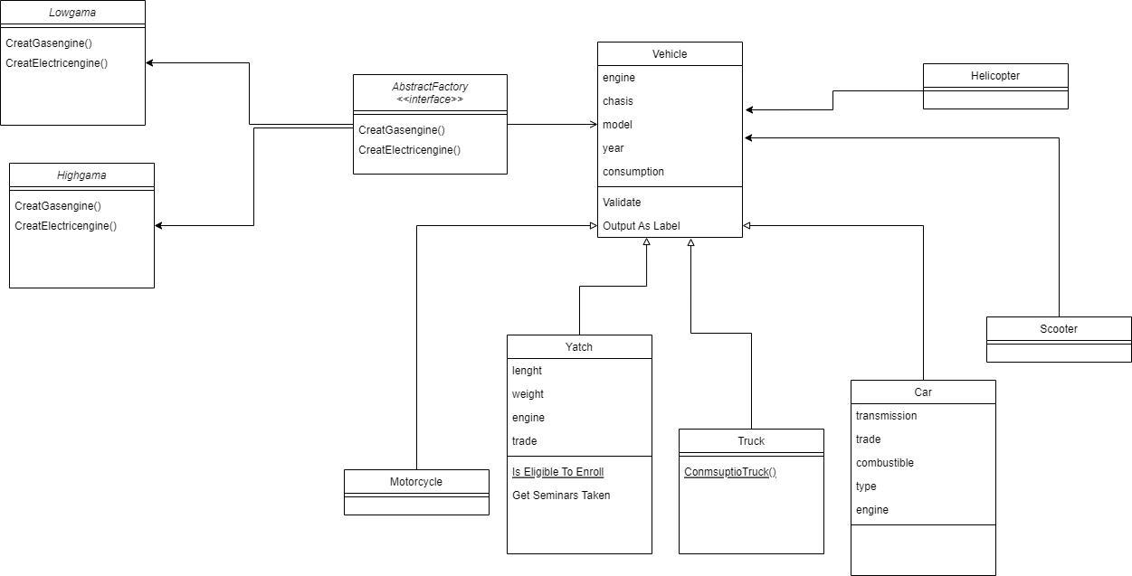

**Recommendations:**

* Make the relationship with the vehicle factory and from there implement singleton and solve the duplication of objects.
* The logic of the new methods has yet to be added.

Carlos Andres Celis-20222020051